Software Requirements Specification
Project: NBP Analyzer
BunniHopPon

Version 1.4 | 29.04.2026

Introduction
The NBP Analyzer is a web application that fetches and processes historical exchange rate data from the National Bank of Poland (NBP) API.
The primary goal of the system is to provide an interface where users can view currency fluctuations (rising, falling, and unchanged sessions) and calculate basic statistical measures (such as median and standard deviation) for specific time periods.

Functional Requirements:
- The system shall support selection of a currency and retrieval of historical data for a specified start date using date picker.
- The system shall allow the user to choose one of the following predefined analysis periods: 1 week, 2 weeks, 1 month, 1 quarter, 6 months, and 1 year.
- The system shall allow the user to choose a currency pair and specify a distinct historical calculation period (a specific past month or past quarter) for change distribution analysis.
- The system shall determine the number of rising, falling, and unchanged sessions in the analysis period for the currency selected by the user.
- The system shall calculate and visualize the following statistical measures: median, mode, standard deviation, and coefficient of variation for the user-selected currency and analysis period.
- The system shall provide the ability to select and analyze exchange rates for the currencies published by the National Bank of Poland (NBP): USD, AUD, CAD, EUR, HUF, CHF, GBP, JPY, CZK, DKK, NOK, SEK.

Non-Functional Requirements:
- The system shall utilize a Continuous Integration (CI) pipeline that automatically runs on the main, release, and develop branches.
- The CI pipeline shall automatically execute unit tests upon every commit.
- A successful pull request to the release branch shall automatically generate a new release tag starting from version 2.0.0.
- A successful pull request to the release branch shall automatically build the static files (HTML, CSS, JavaScript) of the project as a deployable artifact.
- In the event of an API failure, the system shall display a plain-text description of the issue by displaying non-blocking notification banners or alerts within the interface.
- No error shall be presented as a raw exception trace.
- The system shall provide a Single Page Application (SPA) built with React that renders statistical results and trends visually using React Charts without a page reload.

System constraints
- The system shall be designed for modern desktop web browsers (Google Chrome v100+, Mozilla Firefox v100+).
- The system shall not support mobile responsive views.
- The system shall require JavaScript to be enabled on the client browser.
- The system shall use data from the NBP API (api.nbp.pl).
- Due to NBP API limitations, the system shall be constrained to fetching a maximum of 93 days of historical data per request. If a user selects a period longer than 93 days, the system shall perform request chunking.
- The system shall not guarantee data availability for all requested dates due to possible absence of data in the NBP API (e.g., weekends or holidays).
- The system shall retrieve exchange rate data from the NBP API in JSON format.
- The system shall support historical data available from 2002-01-02 onwards due to API restrictions.
- The system shall communicate with the NBP API using HTTPS protocol.
- The system shall retrieve base exchange rates exclusively in Polish Zloty (PLN).
- The system shall dynamically calculate cross-rates to display user-selected currency pairs.
- The system shall not require authentication.

Use case diagram:
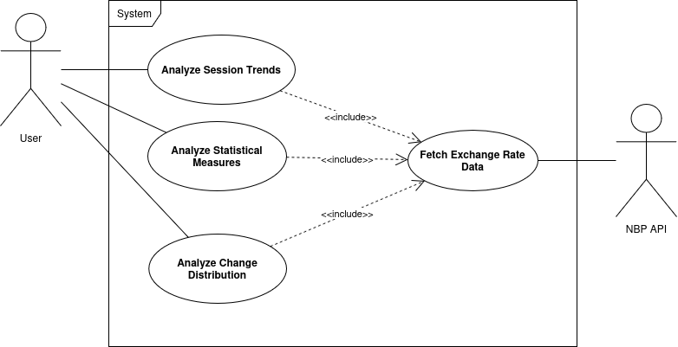

Use cases specification:

Scenario 1 – Analyze Session Trends
- The user selects a currency and a time period
- The system sends a request to the NBP API to fetch exchange rates
- The system receives the data from the API
- The system calculates:
- number of increase sessions
- number of decrease sessions
- number of no-change sessions
- The system displays the results and chart to the user

Scenario 2 – Analyze Statistical Measures
- The user selects a currency and a time period
- The system sends a request to the NBP API to fetch exchange rates
- The system receives the data
- The system calculates:
- median
- standard deviation
- coefficient of variation
- mode
- The system displays the results and chart to the user

Scenario 3 – Analyze Change Distribution
- The user selects a currency and a time period
- The system sends a request to the NBP API to fetch exchange rates
- The system receives the data
- The system calculates daily changes between sessions
- The system groups the changes into value ranges
- The system displays the histogram

Design prototype (Figma):
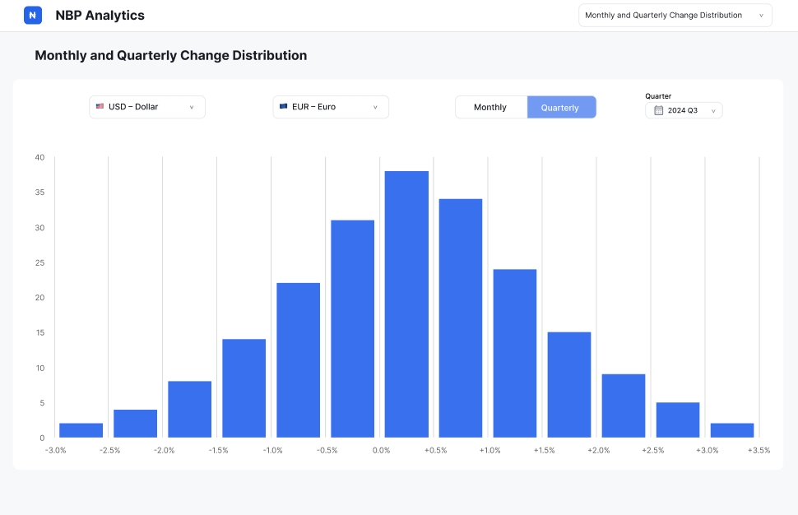

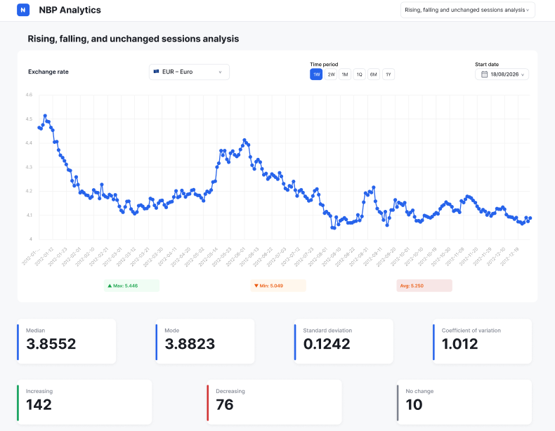

GUI Constraints
- The GUI shall be optimized for a minimum desktop screen resolution of 1920x1080 and shall not guarantee proper layout on smaller screens. On viewports smaller than 1920x1080, standard browser scrollbars may appear, and UI elements will not rearrange.
- GUI shall only be available in the English language.
- The rising, falling and unchanged analysis chart shall restrict the user to selecting only predefined analysis periods: 1 week, 2 weeks, 1 month, 1 quarter, 6 months, and 1 year.
- The GUI shall restrict the change distribution view to only Monthly and Quarterly modes.
- The GUI shall prevent the user from selecting the same currency for both inputs in change distribution analysis.
- The GUI shall restrict currency selection to a predefined list of system supported currencies and shall not allow manual input of currency codes.
- The GUI shall provide a date picker allowing the user to select a specific start date for the session analysis.
- The GUI shall provide a menu allowing the user to select a specific past year, and subsequently either a month or a quarter depending on the active change distribution mode, to determine the calculation period.
- The change distribution analysis shall allow selection only of complete predefined calendar periods: Monthly mode: a full calendar month (e.g., March 2026), Quarterly mode: a full calendar quarter (e.g., Q1 2026).
- The change distribution analysis shall not allow custom date ranges or partial periods (e.g., 15 March – 15 April).
- The GUI shall prevent selection of a start date that results in an invalid date range (e.g., dates which don’t have enough days between selected and present date to display full analysis period or dates before 2002-01-02).
- The change distribution histogram shall display a tooltip containing only the percentage change range (x-axis) and the frequency count (y-axis) when the user hovers over a specific bar.
- The session analysis chart shall display a tooltip containing only the specific Date (x-axis) and Exchange Rate (y-axis) when the user hovers over a data point. It shall not display secondary derived statistics.
- The charts shall not support user-driven zooming, panning, or scaling interactions.
- The GUI shall not support exporting charts as images.
- The GUI shall not support downloading the underlying data.
- The GUI shall restrict users to default statistics and shall not allow adding custom statistical measures.
- During API data fetching for the session analysis and change distribution view, the chart area shall be replaced by a standard loading spinner. Simultaneously, all interactive controls in this view shall be temporarily disabled to prevent overlapping requests.
- The system shall not support dark mode or any other visual theme customization, providing a single fixed interface appearance.
- The charts shall automatically calculate and scale their Y-axes based on the retrieved dataset and shall not provide controls for users to manually override or define the minimum and maximum axis values.
- The static statistical badges below the session analysis chart shall be fixed data points that cannot be clicked or interacted with.
- The change distribution percentage change ranges shall not be customizable.

Gantt diagram (start date: 18.03.2026)
ACTIVITY | PLAN START (days from start date) | PLAN DURATION (in days)
Repository cleanup | 9 | 1
Functional requirements | 11 | 2
Non-Functional requirements | 12 | 2
Use Case Diagrams | 18 | 2
Figma Design | 18 | 4
Specification review & PO approval & eventual refinements | 26 | 10
Project environment configuration | 36 | 3
Unit tests for session trends module | 39 | 7
CI/CD pipeline configuration | 39 | 7
Session trends module implementation | 46 | 7
Statistical analysis module unit tests | 46 | 7
Session trends module GUI integration | 53 | 7
Statistical analysis module implementation | 53 | 7
Release on successful pipeline | 53 | 7
Histogram distribution module unit tests | 60 | 7
Statistical analysis module GUI integration | 60 | 7
Histogram distribution module implementation | 67 | 7
Component Diagram | 67 | 7
Histogram distribution module GUI integration | 74 | 7
System architecture documentation | 74 | 7
GUI refinement | 81 | 7
Sequence Diagram | 81 | 7
Activity Diagram | 81 | 7
Acceptance Testing & Bug Tracking | 67 | 14
Acceptance Test Report | 81 | 7
Final report preparation | 81 | 11

Additional artifacts:
Gantt Diagram
Trello
Figma
GitHub
Google Drive

